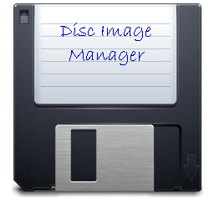
Disc Image Manager
User Guide
Written by Gerald J Holdsworth
Version 1.50

Licence 3
Liability Disclaimer 3
Introduction 4
What Is It and What Can It Do? 4
Downloads 5
Compatibility 6
Thank you 6
Note on images in this document 6
Installation and Basic Usage 7
Using Disc Image Manager 7
Layout 7
Image Toolbar 8
Files Toolbar 8
Partition Toolbar 8
Tools Toolbar 8
Working With an Image 10
Image Contents Pane 10
File Details Pane 11
Changing The Details 11
Free Space Map 11
Downloading (Extracting) Files 12
Adding Files 12
Import of Another Image Contents 13
Converting Two Single Sided DFS Images to Double Sided 13
Adding the Contents of a SparkFS or PackDir archive 13
Deleting Files and Directories 13
Creating a New Directory 14
Copying and Moving Files 14
Searching for Files 14
Repair ADFS Broken Directories 15
Change Interleave Method 15
Defragmenting 16
Working With Partitions/Sides 17
Note about Acorn File Server 17
Adding an Acorn File Server or DOS Plus Partition 17
Acorn File Server Password Files 18
Removing or Saving a Partition 18
Creating a New Image 20
ADFS Hard Drive Image 20
DOS Hard Drive Image 20
Commodore Amiga Hard Drive Image 21
Acorn File Server 21
The File Viewer 22
Preferences 24
Window Texture 24
Track Order 24
DFS Validation 25
Miscellaneous 25
Command Line Options 26
Entering The Console 26
Using the Console 26
Console Commands 26
Credits 31

Licence
Disc Image Manager is distributed under the GNU GPL v3 licence:
This source is free software; you can redistribute it and/or modify it under the terms of the GNU General Public Licence as published by the Free Software Foundation; either version 3 of the Licence, or (at your option) any later version.
This code is distributed in the hope that it will be useful, but WITHOUT ANY WARRANTY; without even the implied warranty of MERCHANTABILITY or FITNESS FOR A PARTICULAR PURPOSE. See the GNU General Public Licence for more details.
A copy of the GNU General Public Licence is available on the World Wide Web at http://www.gnu.org/copyleft/gpl.html. You can also obtain it by writing to the Free Software Foundation, Inc., 51 Franklin Street - Fifth Floor, Boston, MA 02110-1335, USA.

Liability Disclaimer
While I, Gerald Holdsworth, make every effort to deliver high quality products, I do not guarantee that my software is free from defects. My software is provided “as is,” and you use my software at your own risk.
I make no warranties as to performance, merchantability, fitness for a particular purpose, or any other warranties whether expressed or implied.
No oral or written communication from or information provided by me, Gerald Holdsworth, shall create a warranty.
Under no circumstances shall I, Gerald Holdsworth, be liable for direct, indirect, special, incidental, or consequential damages resulting from the use, misuse, or inability to use this software, even if I have been advised of the possibility of such damages.

Introduction
Disc Image Manager originally started out as a Delphi class, TDiscImage, written for inclusion into Repton Map Display so that it could read Repton data files direct from disc images. To test that the class worked OK, and as a demo application as I released the source code into the public domain, I wrote a GUI front end for it called Disc Image Reader.
This project was still in Delphi so, therefore, Windows only. It was not until November 2020 that someone on the Stardot forum asked about accessing Acorn DFS images from MacOS. Owning a Mac myself, and with it being my main computer (relegating the Windows laptop to a secondary PC), I also noticed this hole in the ‘market’. So, I decided it was time to port this across.
However, to do so, I needed to port the project into Lazarus (basically the free, multi-platform, version of Delphi). Previous attempts at using this product had failed, but this time I was determined. So, with Lazarus newly installed on my Mac, I then imported Disc Image Reader and, to my surprise, it worked with only a few minor changes. Finally, we had Disc Image Reader running on macOS. That became version 1.05, and further development commenced.
The first thing to add in was make the application write back to the images. I had already written the code to write back to a DFS image, but never tested it. And thus, Disc Image Reader became Disc Image Manager. It also found a new home on the Internet, at GitHub, in addition to my own website.
Roll onto the latest version and it has come on beyond what I expected it to be at the start. With the support, bug reports, and suggestions from the Stardot community, development has come on in leaps and bounds. So, I thank you all who use this for, well, using it, and I hope you find it useful.

What Is It and What Can It Do?
Disc Image Manager is an application for managing retro-computer disc images. Basically, you can read and write to them using a modern-day operating system. So, why would you want to do that? If you are asking that question, then you probably should not be here!
The formats it can deal with, as of the current version, are:
Format | Readable | Writeable
Acorn DFS | Yes | Yes
Watford DFS | Yes | Yes
Acorn ADFS Old Map | Yes | Yes
Acorn ADFS New Map | Yes | Yes
Commodore 1541 | Yes | Yes
Commodore 1571 | Yes | Yes
Commodore 1581 | Yes | Yes
Commodore AmigaDOS OFS | Yes | Yes
Commodore AmigaDOS FFS | Partial | Partial
Commodore AmigaDOS Rigid Disc | No | No
Sinclair Spectrum +3/Amstrad | Yes | No
MMFS (Acorn) | No | No
Acorn File Server Level 2 | Yes | Yes
Acorn File Server Level 3 | Yes | Partial
!Spark (RISC OS) | Yes | Yes
!PackDir (RISC OS) | Yes | No
DOS Plus (Master 512) | Yes | Yes
DOS FAT12 | Yes | Yes
DOS FAT16 | Yes | Yes
DOS FAT32 | Yes | Yes
Acorn Cassette Filing System | Yes | Yes
Acorn ROM FS | Yes | Yes
ISO 9660 and Joilet | Yes | No
Where the functionality is listed as ‘No’, this is a planned future development. In addition, Disc Image Manager can handle up to 2 partitions in some cases – i.e., ADFS+AFS; ADFS+DOS; DFS DSD. The handling of three or more is also a planned future development.

Downloads
Disc Image Manager can be downloaded from GitHub:
https://github.com/geraldholdsworth/DiscImageManager/releases
Or from my own website:
http://www.geraldholdsworth.co.uk/index.php?link=DiscImageReader
I have supplied the binaries, either zipped or packaged, for the following OSes and CPUs:
- macOS 32 bit
- macOS 64 bit
- macOS ARM
- Windows 32 bit
- Windows 64 bit
- Linux 32 bit
- Linux 64 bit
- Raspbian OS 32 bit ARM (Raspberry Pi)
- Raspbian OS 64 bit ARM (Raspberry Pi)
You can also contact me via the Stardot forum, or through email: gerald@geraldholdsworth.co.uk.
And the complete source code, ready for recompiling for any system that Lazarus (current version 4.4) will run on:
https://github.com/geraldholdsworth/DiscImageManager

Compatibility
Although not extensively tested on all systems, the provided binaries should work on the following systems:
Windows: XP, 7, 8, 10 and 11 (both 32- and 64-bit versions are provided). However, it has only been tested on Windows 10 and 11 64-bit.
Linux: This has been tested on Linux Mint Cinnamon 64 bit, and Raspbian OS 32 and 64 bit.
macOS: From Leopard onwards. My main computer is a Mac which, currently, gets the latest updates from Apple.
It has also been lightly tested with ‘High DPI’ setups – i.e., under Windows or Linux you can magnify the screen beyond 100%. I have not found a way of doing this under macOS yet.

Thank you
Many thanks to the users and contributors of the Stardot forum whose feedback and advice has been greatly appreciated. Also, a big thank you to Jasper Renow-Clark who helped me with the ADFS formats in the beginning, before this project started.
This project was conceived as a module to the Repton Map Display application, with this application just being a demo (and for me to try the code out with). In December 2020, it became the Disc Image Manager.
Additional thanks go to Robert Sprowson for his help with working out the parameters for ADFS Hard Drive images, and to David Pilling for his help with the Spark module.
Suggestions, bug reports, or whatever please do not hesitate to email me on gerald@geraldholdsworth.co.uk, or contact via Stardot forum.

Note on images in this document
Most of the images used in this document are taken from earlier versions of the application (running on macOS), so they may appear slightly different from what you see.

Installation and Basic Usage
All the pre-built binary downloads are provided in either a ZIP archive (Windows and Linux) or a DMG file (macOS). To install them, just open the archive/package and drag the application to wherever you wish it to be. It is just a single file (well, directory in the case of macOS) and can be run anywhere. There are no special installers, or anything special you need to do. It will just run. OK, you might get an annoying little message from the OS saying it is not from a registered developer, but once past that, it will just run.

Using Disc Image Manager
Once you have it running you will be presented with the main window (note that all screen shots are taken from the macOS version). Along the top, in Windows and Linux, will be the main menu bar (this is located on the macOS menu bar at the top of the screen, in macOS). Below this will be the tool bars. All the buttons in the toolbars are replicated through the main menus and, for some, also in the context menu (more on this later).
Below this will be two panes – Image Contents and File Details. The former will display the contents of a disc image, while the latter will display the file (or directory) details on the selected file (or directory).
Finally, along the bottom is the status bar which gives various information about the opened image.

Layout
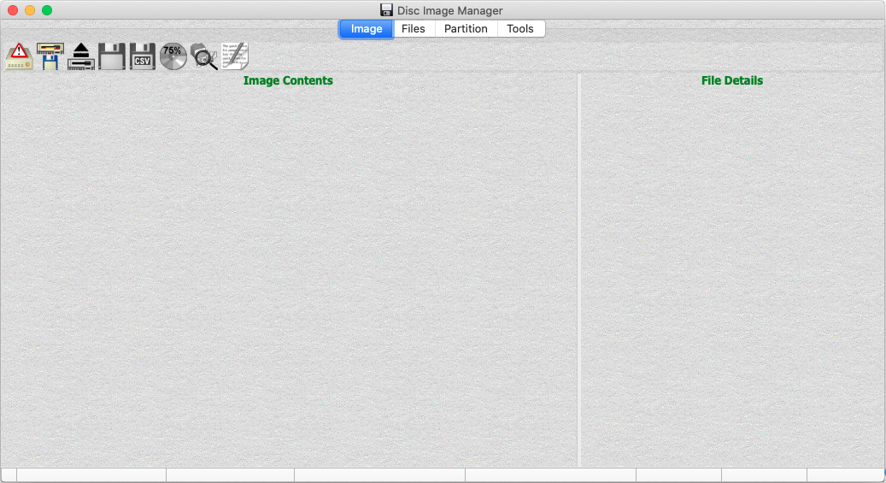
The toolbar buttons are split into four categories, each on its own toolbar, accessible via use of the tabs, which can be hidden using the menus. These are:
- Image toolbar
- Files toolbar
- Partition toolbar
- Tools toolbar
The buttons in each tool bar are:

Image Toolbar
- New Image File: creates a new image.
- Open Image File: opens an image file.
- Close Image File: closes the currently open image.
- Save Image As: Saves the currently open image.
- Save File Details As CSV: Saves the file details, of all the files on the image, as a CSV file.
- Display the Free Space Map: Displays the free space map, along with some other details about the image. It will also allow you to change some of these details.
- Open File Search Window: Allows you to search the image for one or more files or directories by filename or filetype.
- Show Image Report: Displays low level details about the loaded image.

Files Toolbar
- Download File(s): Allows you to extract (download) files from the image onto the host filing system.
- Add File(s): Does the opposite of the above.
- Rename File: You can rename a file or directory here.
- Show File Viewer: This will show you the contents of the selected file. This will include a hex dump but may also include other views.
- New Directory: Creates a new directory on the image, depending on the format.
- Delete File: Removes a file (or directory) from the image.
- Duplicate File: Clones a file within the same directory.

Partition Toolbar
- Add Password File: Creates and adds a new password file for Acorn File Server images.
- Edit Password File: Allows Acorn File Server password files to be edited.
- Delete Partition: Deletes an Acorn File Server or DOS partition from an ADFS Hybrid, or one side from a double sided DFS image.
- Save Partition: Saves either the ADFS, the Acorn File Server, or the DOS partition as a separate image. This will also save either side of a double sided DFS image as a single sided image.
- Add Partition: Adds a new Acorn File Server partition into an ADFS 8 bit image, or a second side to a single sided DFS image.

Tools Toolbar
- Repair Broken ADFS Directories: This tool will find and attempt to repair any broken directories on an ADFS disc.
- Change Interleave Method: This tool, for ADFS L, ADFS/Acorn File Server Hybrids, and Acorn File Server images, can be used to change how the data is laid down within the image file.
- Defrag: Simply…defragments the files on the image (similar to *COMPACT with ADFS).
- Multi CSV Output: A simple tool where you can select one or more image files and output the CSV of each image in turn. This is a batch file version of the “Save File Details As CSV” function of an open image.
- Preferences: Customise various aspects of the application.
- About Disc Image Manager: What it is, who wrote it, what version and some other information.
The status bar, along the bottom, will give this information (when an image is opened), from left to right:
- Modified: Displays a small icon if the image has been modified since the last open/save.
- Image format: What system the image is for, along with what ‘shape’ it is.
- Disc title: If available, the title of the disc, of the currently selected partition/side.
- Capacity: The maximum capacity of the image, or currently selected partition/side.
- Free Space: The amount of free space left on the image, or currently selected partition/side.
- Single/Double Sided: Indicates whether this is a single sided or double sided DFS image. Blank if not DFS.
- ADFS Map Type/Amiga FS type/DOS type: Indicates whether the ADFS map is old or new; the AmigaDOS is OFS or FFS; or the DOS is FAT12, FAT16 or FAT32.
- ADFS or Amiga Directory Type: Indicates whether this is an ADFS old, new or big directory, or if it is an Amiga directory or directory cache.
As discussed earlier, the four toolbar tabs can be hidden. The File Details pane on the right (see next chapter) can also be hidden, as can the status bar along the bottom, using the ‘View’ menu.

Working With an Image
OK, so let’s open an image. There are three ways of doing this – either click on the toolbar button, through the main menu or, simply, just by dragging the file over the main window and dropping it. At this point, I will point out that you can do most things by dragging and dropping, or by not using the menus or toolbar.
Assuming it is a file that Disc Image Manager recognises and supports, you should get a populated display:
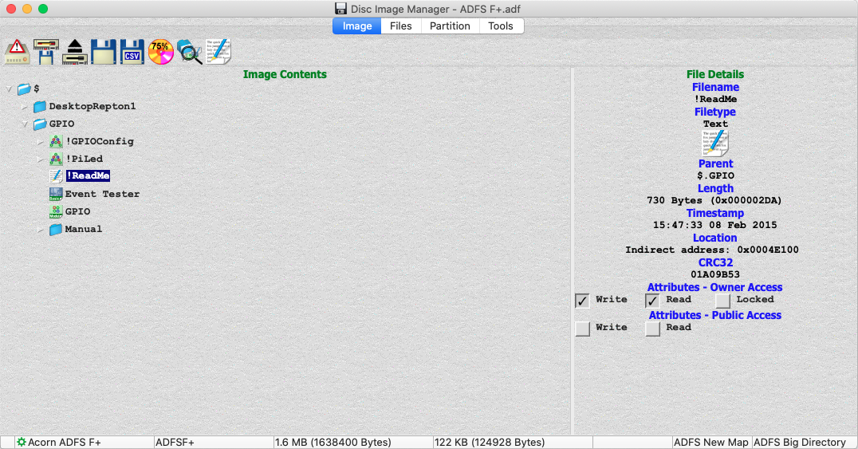
Now we have one open we can look at the two panes in greater detail. Incidentally, you can resize the main window by clicking and dragging one of the edges or corners, and the two panes using the vertical sizer between them.

Image Contents Pane
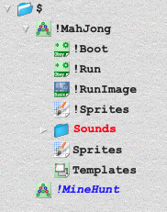
This shows the contents of the image in a tree format. You can slow double click to rename it. A directory can be expanded or contracted using the little arrow to the left of the item (if it has any children).
Some directories have different colours and font styles:
- Black shows normal objects.
- Red shows a broken directory in ADFS.
- Blue, and in italic, shows a directory which has yet to be read in (see preferences later).
Additionally, a file may be in green, meaning that it is the currently open DOS partition. These files cannot be deleted.
Items can be selected, and their details will show up in the File Details Pane on the right. Right clicking on an item will bring up the context menu, which replicates the file functions in the main menu and tool bar.

File Details Pane
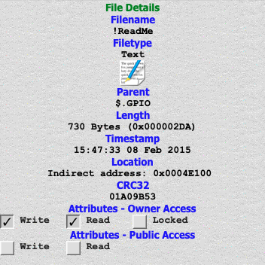
Some of the fields displayed will be editable, while the others you can copy to the clipboard just by clicking on them.
The Filename, Parent, Length, Location and CRC32 can all be copied to the clipboard (renaming a file or changing its parent will be covered later).
The Filetype, Timestamp, Directory Title, Load address and Execution address can be changed by clicking on them. The Attributes can be changed just by ticking, or unticking, the appropriate box.
Not all fields will be available for all files on all systems. As you can see here, the Load and Execution addresses are not available as they are encoded for the filetype and timestamp. And the Directory Title is not available because we are looking at a file. The format of the location will also change depending on the file system.

Changing The Details
So, let’s start by changing the filetype. Click on the filetype text or icon to open a small menu window:
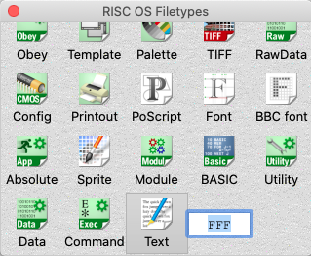
This will list all the filetypes known to the application (in fact, it lists all those that are known and there is a filetype icon available). Right at the end is an editable field for entering a filetype other than that listed. Just click on the desired filetype, or enter your own and press Enter, to change.
To change the Directory Title, again just click on it to make the field editable (unless, like here, it is an ADFS ‘+’ format that does not have directory titles). Press Enter once you are happy with your change. Changing the Load & Execution addresses, and timestamp, are done in the same way.
Renaming a file is achieved by slow double clicking on the file – this means, click to select a file, then click again to turn the filename editable. If you are too fast, it will open the file viewer (more on this later). Press Enter to finalise the change.
If, with any of these changes, they are invalid to the file system, then they will revert. So be aware of the filing system restrictions (e.g., DFS filenames are 7 characters in length, maximum). You will also find that you will not be able to do any edits when you have multiple files/directories selected.

Free Space Map
There are some more changes you can make, but these are achieved through the free space map window:
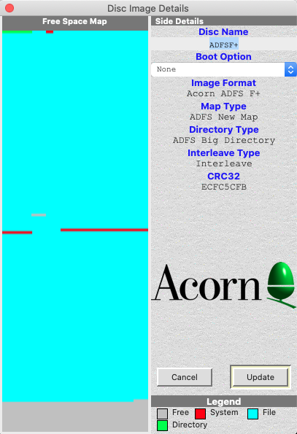
On the left-hand side, you will find a nice graphical display representing the disc. It will show free space, space used by files, space used by directories and space used by the system.
On the right-hand side the disc name and boot option will be displayed, along with a repeat of some of the image’s information.
The Disc Name and Boot Option are editable, and you can simply click on them to change. Once you are happy with your changes, click on Update to make the change. Clicking on Cancel will forget all changes in this window.
If you have a double sided DFS image open, you will get two free space maps, and two boxes for the Disc Name and Boot Option.
Not all formats will give this display and, therefore, are not editable.
Below this will be, depending on format:
- Image Format: Textual representation of what the format is;
- Map/FAT Type: For ADFS and Amiga, the type of map, and DOS for the FAT type;
- Directory Type: For ADFS and Amiga, the type of directory;
- Interleave Type: For DFS double sided, ADFS ‘L’, and Acorn File Server, the interleave method used to open this image;
- CRC32: The CRC32 number so you can quickly check if the file is the same as another.

Downloading (Extracting) Files
One thing that most people will want to do is to get files off the image and onto the host filing system. At the time of writing, dragging a file out of the application is not possible. So therefore, we are left with the other option of using the toolbar button, or the main menu. You can also right click to open a context menu which will have this option listed (along with Rename).
Select the file, or files, you wish to download and use your preferred method (toolbar/main menu/context menu) to open the Save As dialogue box. This is an OS derived dialogue so will behave as others do on your operating system. So simply navigate to where you want to download these files to. When they are downloaded, they will have an ‘inf’ file alongside (unless you have selected not to – see Preferences). This gives other information about the file (such as load and execution addresses) which would otherwise be lost. Full details about this file can be found at the end of this guide.

Adding Files
Another operation that people will want to do is to add files, from the host operating system to an image. This can be done by dragging and dropping, just like opening an image. Disc Image Manager will also take account of any ‘inf’ files and skip over such files if they are part of the selection – I have seen similar utilities to Disc Image Manager that attempts to import the ‘inf’ files if they are selected.
You may find that the toolbar button, and menu item, for adding a file is greyed out. This is because a file can only be added if a directory is selected, where it will be added to that directory. Dragging and dropping a file will automatically select the root if none are selected.

Import of Another Image Contents
Something to watch out for – if you have an image open and you drag another image in, Disc Image Manager will recognise this and ask you if you wish to import the contents into this image. You might have wanted to open the new image or import it as a file. Well, you are given these options too. If you choose to import, then the following dialogue will open giving you the option of which files to import and which to leave:
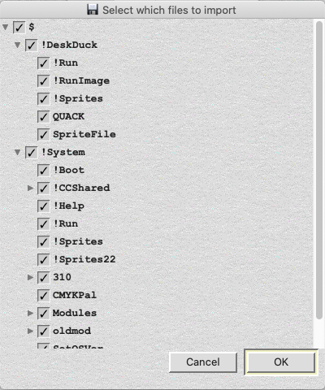
Just simply untick those which you don’t require and tick those that you do. You will find that as you tick, or untick, items the parent directory will change from ticked (), or unticked (), to an intermediate state ().
Also, ticking, or unticking, a directory will cause all the contents, including any sub-directories and their contents, to be ticked or unticked. It can therefore be seen that if you tick the root ($) then the entire contents will be selected, and conversely, unticking the root will cause the entire contents to be deselected.
Once you are happy with your selection, just click on OK to commence the import, or Cancel to cancel the entire operation.
Disc Image Manager will check to make sure that the current open image is of a format suitable to receive the contents and a warning is issued if not. During the import any errors are ignored and skipped but logged and reported to the user once the operation has completed.

Converting Two Single Sided DFS Images to Double Sided
If you have a single sided DFS image open and you go to add another, as above, you will get a different prompt – that of whether to import the contents (as above), or convert the currently open image to a double sided image, with the incoming image as the second side.

Adding the Contents of a SparkFS or PackDir archive
Disc Image Manager is, by default, set to treat SparkFS and PackDir images as a filing system and, hence, will open them normally. However, Disc Image Manager can be configured to treat these as a file.
In these cases, if Disc Image Manager recognises the file as a Spark or PackDir archive it will inflate and add the contents (if you wish). But if the uncompressed contents do not fit on the disc, you will not get the option and the file will be added as is instead.

Deleting Files and Directories
To delete a file or directory, just select it and click on Delete File (either from the toolbar, main menu, or context menu). A word of warning – if you have multiple files or directories selected, then they will all be deleted, and if you have a directory selected then the entire contents, including sub-directories, will be deleted. But you will be presented with a confirmation box before this happens.

Creating a New Directory
This is very simple – just click on Create Directory toolbar button, or use the appropriate menu item, and a new directory is created (if the filing system supports directories). It will be given a default name which you can then change using the rename procedure above.

Copying and Moving Files
Files can be copied from one directory to another or, in the case of DFS, from one side to another. They can also be moved. This is done a similar fashion to the host operating system. However, at the time of writing, copying to the clipboard then pasting back is not available.
In the directory listing pane (Image Details), select a file, directory. Then you can just drag it to the desired directory (side) on the same image. While in the drag/drop operation, pressing CTRL (Windows and Linux) or ALT (macOS) will result in the file being copied (indicated by the plus icon ), while pressing SHIFT will result in the file being moved. The destination directory is indicated by it being selected, and opened if not already done so, as you hover over it. Once happy with the destination, just drop the file.
Copying files into the same parent directory (you cannot move files into the same parent as this would be pointless) has the effect of cloning the file. Currently, this cannot be done with directories. This cloning operation can also be achieved by using the toolbar button, main menu item or context menu item.
At the time of writing, only single files, or directories, can be operated on in this fashion.

Searching for Files
Clicking on the Search button will open the File Search dialogue box:
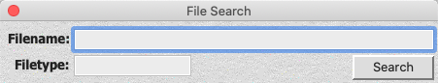
Just enter your search criteria and press Enter or click on Search. Both fields can be filled out if you so wish to search on both simultaneously. You can use wildcards:
- ‘#’ will match any single character: ‘a#c’ will find ‘abc’, ‘acc’, ‘adc’, etc.
- ‘*’ will match zero or more characters: ‘ab*’ will find ‘ab’, ‘abc’, ‘abcd’, etc.
The search is case-insensitive, so ‘abc’ is the same as ‘ABC’ and ‘Abc’.
The results will be listed below:
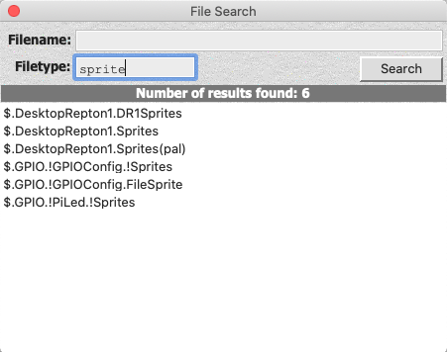
Double clicking on one of the results will select it in the main window.
Note that if you have selected the option not to scan sub directories when opening, then only the directories which have been ‘seen’ will be searched in.

Repair ADFS Broken Directories
Disc Image Manager will attempt to open and display ADFS directories if they are broken or not. Directories will be displayed, on the right-hand pane, as broken along with an error number. At the time of writing, the following will attempt to be repaired:
- Broken directory due to the start and end sequence number not matching: When ADFS writes to a directory, it updates the sequence number (the number in brackets at the top of a directory display in 8-bit ADFS) at the head of the directory, makes the write, then updates the sequence number in the tail. This means that if anything happens during the write, it will result in a broken directory. Bit 0 of the error code is set in Disc Image Manager (0x01).
- Broken directory due to the start and end identity name not matching or incorrect (old and new directory): In ADFS, directories are identified by the string ‘Hugo’ (after Hugo Tyson) or ‘Nick’ (after Nick Reeves). There is an id in the header and the tail. Bit 1 of the error code is set in Disc Image Manager (0x02).
- In addition, if the start or end do match but are not ‘Hugo’ or ‘Nick’ (old directory) then bit 6 of the error code will be set (0x40).
- Broken directory due to the start and end identity being incorrect (big directory): As above, but with big directories the id is ‘SBPr’ in the header and ‘oven’ in the tail (after Simon Proven). Bit 2 of the error code is set in Disc Image Manager (0x04).
- Broken directory due to incorrect cyclic redundancy check: To ensure the integrity of the directory a CRC is calculated based on the contents and stored in the tail. Old directories this can be zero. Bit 3 of the error code is set in Disc Image Manager (0x08).
- Broken directory due to the directory not being sector aligned: Bit 5 of the error code is set in Disc Image Manager (0x20).
There are some other cases that will cause a broken directory, which will set bit 4 of the error code, if detected (0x10). The main one is the use of interleaved images (mainly with ADFS ‘L’ shape discs). If a disc is read in and assumed interleaved where it is not, then the result will be broken directories. Disc Image Manager will detect these, as the directory will not be where it should and therefore is unlikely to be able to be repaired. We will cover interleaved images later.
In addition, Disc Image Manager will only repair those directories that have been ‘seen’. So, by selecting the option not to scan sub directories on opening can affect which directories are fixed.

Change Interleave Method
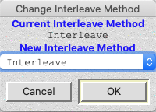
As alluded to above, and covered again in Preferences, the interleave method can be quite important. For example, an ADFS L image is expected to be interleaved when read by BeebEm. If it is not, ADFS in BeebEm will report that the image is bad (or, rather, that it has broken directories). Now you would think that, therefore, all ADFS L images you come across are interleaved…but, the reality is, they are not.
So, using this tool, you can change the interleave method from the currently detected (or forced – see later) method to another method. You will not see any difference in the display in Disc Image Manager, aside from the Image Details dialogue will report what the current interleave method is.

Defragmenting
The way files are saved onto images is to store them in a fixed size allocation unit. You may have come across the term “Large File Allocation Unit”, of LFAU for short, when formatting hard drives. This is the smallest size that a file can take up on a disc.
With fragmented formats (such as New Map ADFS, Acorn File Server, and Commodore formats) the different fragments of files can be scattered across the disc’s surface, with each fragment taking up a minimum of an LFAU (although New Map ADFS introduced the concept of sharing).
Another example would be, for example with DFS, where a file is deleted. This leaves a ‘hole’ in the free space map. When a smaller file is subsequently saved, this will be inserted into this ‘hole’. But, if a bigger file is saved, this will not fit in the ‘hole’, so a bigger ‘hole’ is needed to be found.
The defrag feature of Disc Image Manager simply clones the partition or side (as this can work on multi-partition images), deletes everything in the original, then re-imports all the files back in, thereby re-organising them and effectively defragmenting the image.

Working With Partitions/Sides
There are some formats that Disc Image Manager can deal with that have a second partition. This second partition is usually of a different format. Currently, those images are double sided DFS (where the partitions are called sides, as they are different sides of a physical disc), ADFS with Acorn File Server Hybrids, and ADFS with DOS Plus Hybrids.
By Acorn FS nature, the format is usually stored with an ADFS header anyway (Level 3), so having an ADFS directory structure in addition to an Acorn FS part is not that uncommon.
Disc Image Manager has some functionality to deal with these partitions. The Acorn FS partition of an ADFS/Acorn FS Hybrid has, as the root, ‘AFS$’ (as opposed to ‘$’) to distinguish it from the ADFS root – this becomes important when searching for files. The partitions can also be saved out, separately, or deleted, separately. This includes converting two single sided DFS images to a double sided image (as noted above) and splitting a double sided image into two single sided images.
A partition, or side, can be saved out as a separate image using the ‘Save Partition’ button (or ‘Save Side’), or it can be removed from the image using the ‘Delete Partition’ button (or ‘Delete Side’). Both operations are, in effect, the same thing.
When splitting ADFS/Acorn FS partitions in this way, the Acorn FS partition will mark up the entire part where the ADFS was as used space, instead of shuffling all the files around. The ADFS partition, however, will clear the Acorn FS partition and mark it as free space. If you wish to shuffle the files around, it might be easier to import the resultant Acorn FS image into a new, blank, Acorn FS image.

Note about Acorn File Server
It was discovered that Acorn changed the layout of the Level 3 format around 1988. As of version 1.39 of Disc Image Manager, you can no longer create an image or partition greater than 127MB in size, until this format is figured out and documented.

Adding an Acorn File Server or DOS Plus Partition
You may want to add an Acorn FS or DOS Plus partition to an existing ADFS image. This can be done using the Add Partition button. This will only work with the 8-bit variants (i.e., Old Map/Old Directory). The maximum size is determined by the amount of free space left on the image, and you will be able to select how big you want the partition to be:
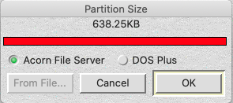
The minimum size will be 9 sectors, or 2.25KB. This is to allow for the two Acorn FS headers, the root directory and the root header, the map, and a bit of space to make it useful. This is also enough space for a DOS Plus FAT, the root, and some useful space. The resultant image will use the same interleave as the donor image, either automatically detected, or specified through the preferences page.
Adding a Second Side to a Single Sided DFS image
As we have seen above, this can be done by opening another single sided DFS image while one is already open. However, you can also do the same using this same button described above. Only difference is that you will also be able to add a blank second side, and it does not need to be the same number of tracks as the first side:
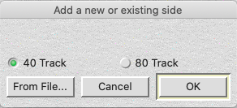
You can also use the ‘From File’ button to add an already existing single sided image as a second side, as before.

Acorn File Server Password Files
One feature of Acorn File Server is the use of password files to allow certain users access to the server. These files are not required to be present. But, if you have an image without one (or create an image without one – see next chapter), you can add one by clicking on the ‘Add Password File’ button. This just adds a basic file with the ‘Syst’ user.
If the image already has such a file, this can be edited by clicking on the ‘Edit Password File’ button:
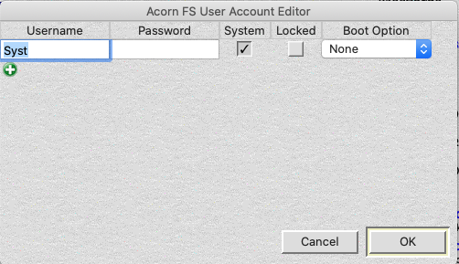
This will list, in the order of appearance in the file, all the usernames, passwords and their attributes. There is no checking for duplicates, with the only check being that Syst must exist, somewhere, and that it is a System account.
The locked option is only valid for Level 3 systems, and the username length varies between Level 2 (10 characters) and Level 3 (20 characters).
Clicking on the plus icon will add another row. To remove an account, just blank out the username. These entries will be skipped when OK is clicked.

Removing or Saving a Partition
Clicking on the Save Partition As button, while a hybrid image is open, will save the selected partition as a separate (and non-hybrid) image.
Saving the ADFS partition will result in extending the ADFS image size, so it takes over the entire space where the other partition existed. Saving the Acorn File Server or DOS partition will just result in the partition, with no resizing. This operation does not change the original image.
Similarly, clicking on Delete Partition will remove the selected partition resulting in the other partition being the sole file system on the image. This operation will change the original image.
Both buttons can be used with double sided DFS images to split them into single sided images. However, because of the way that Commodore 1571 images are laid out, it is not possible to split these into 1541 images or join two 1541 images into a single 1571 image.
NOTE: The separating of the Acorn File Server partition is still under development and currently does not result in a viable image. In addition, if a DOS partition does not have a viable header, then this will not be created on the resultant image.

Creating a New Image
Disc Image Manager can create new, blank, images. These can then either be used to add files to, or for use in an emulator. To do this, click on the New Image button to open the New Image Dialogue box:
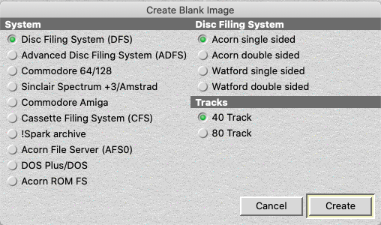
Simply just select the System on the left-hand side, then the format on the right-hand side. Some formats are unavailable and will cause the Create button to be greyed out.
Once the new image has been created, it will be displayed in the main display window and the root will automatically be selected.

ADFS Hard Drive Image
Selecting to create an ADFS Hard Drive, and clicking on Create, will result in a further dialogue box:
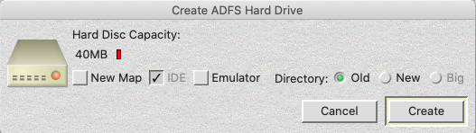
Here you will need to specify the size (minimum of 20MB, maximum of 1GB), map type (New map or not) and Directory type (Old, New or Big). Some ADFS restrictions:
- You can only have an old or new directory with an old map.
- You can only have a new or big directory with a new map.
- Old map only supports up to, and including, 512MB. Above this it will be new map.
The maximum size of 1GB is purely down to memory restrictions. At the time of writing, Disc Image Manager loads the entire image into memory. Once the code is changed so that it opens and accesses the image directly from the disc, the 1GB upper limit can be removed.
The option ‘IDE’ will adjust the disc record for IDE images, otherwise they will be adjusted for ST506 images. This is only valid on new map images. The option ‘Emulator’ will add a 512-byte header, full of zeros, at the top of the file.
Clicking on Create will then create the hard drive image.

DOS Hard Drive Image
Similar to the ADFS Hard Drive image creation, a DOS Hard Drive can be created, and works the same as ADFS.
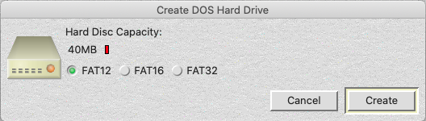
The maximum size will change depending on the FAT type you select:
- FAT12 maximum size is 500MB (with 512byte sectors)
- FAT16 maximum size is 1000MB (with 512byte sectors).
- FAT32 is restricted to 1GB, like ADFS.

Commodore Amiga Hard Drive Image
Sometimes referred to as a ‘hardfile’, this will simply create an HDF file for use in an Amiga emulator (for example, FS-UAE). The file system is automatically selected to be Fast File System.
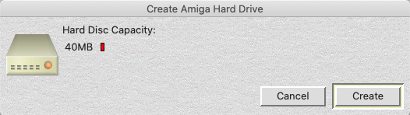

Acorn File Server
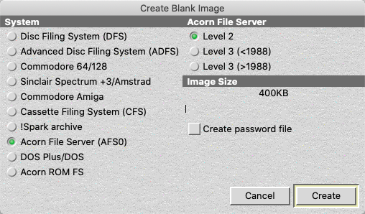
Clicking on Acorn File Server will present you with an option for the image size and whether you wish to create a password file (with just the ‘Syst’ username in).
The minimum capacity, for Level 2, is 400KB and for Level 3 is 640KB, while the maximum is 500MB.
Note: The maximum Acorn File Server size is temporarily restricted to 127MB for technical reasons, and the two Level 3 options will result in the same format currently.

The File Viewer
Double clicking on a file will open it in a separate window as a hex dump, allowing you to see the contents. But, if Disc Image Manager recognises this file as something it can display, it will:
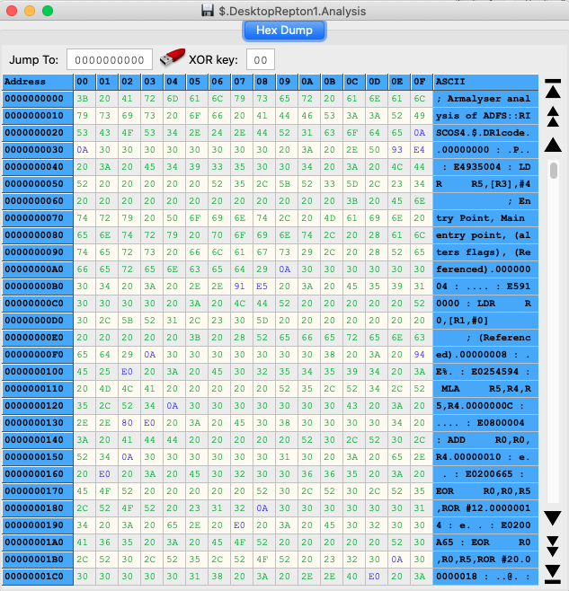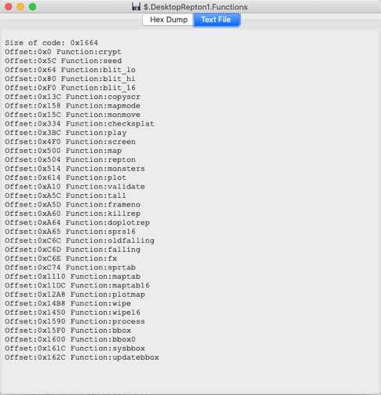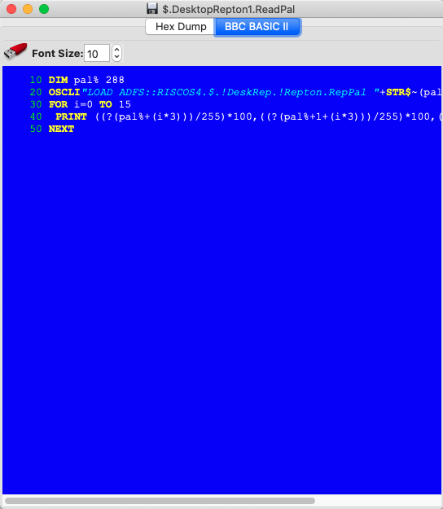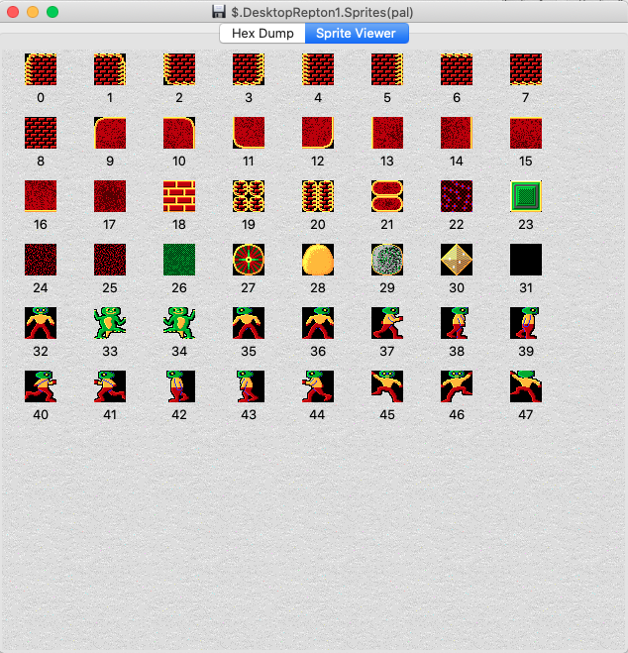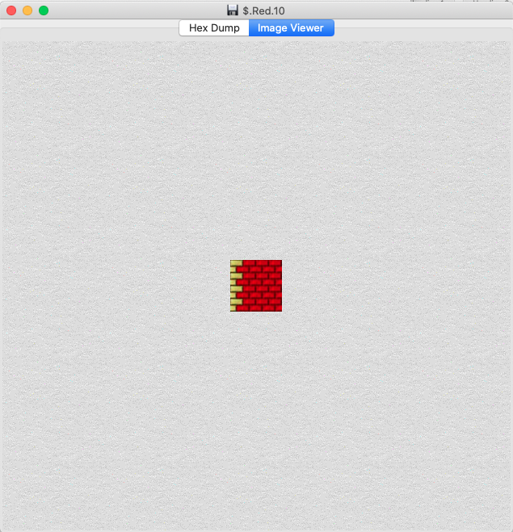
Above we have, from left to right and top to bottom:
- Hex dump view: Every file will have this. Accessible via the ‘Hex Dump’ tab at the top.
- Text view: If Disc Image Manager determines that the file is pure text (only contains characters in the ASCII range 32-126 or 9, 10 or 13) then it will display it as text.
- BBC BASIC view: If Disc Image Manager determines that the file is a BBC BASIC file, it will detokenise and prettify the BASIC file. On this page you have the facility to increase or decrease the font size, or to output the BASIC listing to a text file.
- RISC OS Sprite view: If Disc Image Manager determines that the file is a RISC OS sprite file, the contents will be displayed as such.
- Image view: Other image formats (Windows Bitmap, PNG, or JPEG) will be displayed here.

Preferences
Clicking on the Preferences button (or using the main menu) will open the dialogue box so that Disc Image Manager can be customised.
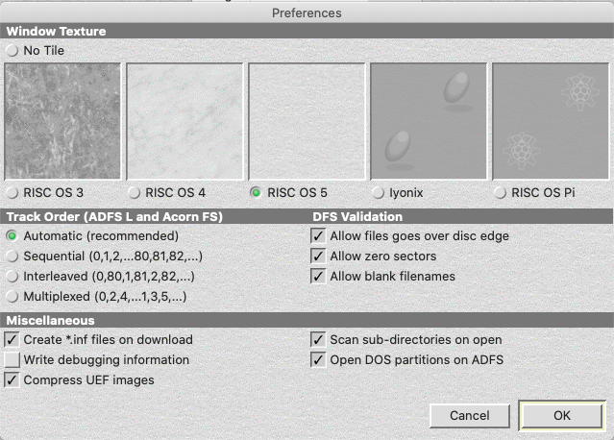
The options available here are:

Window Texture
There are six options for the background texture of each window within Disc Image Manager:
- None: all windows will have a plan background;
- RISC OS 3 style;
- RISC OS 4 style;
- RISC OS 5 style;
- RISC OS on Iyonix style; and
- RISC OS on Raspberry Pi style.
In addition there is also the following two options where the RISC OS styling can be turned on or off completely:
- Native OS; and
- RISC OS

Track Order
We touched briefly on interleaving earlier on. This is done on all DFS Double Sided images, most ADFS ‘L’ images, and some Acorn FS images. As pointed out earlier on, if an ADFS L image is loaded as interleaved but is not interleaved, then it may well result in some broken directories. This is how the Automatic option works – it tries loading the image as interleaved and counts the number of broken directories. If there are any, it reloads it as multiplexed. Then, if there are still some broken directories, it tries sequential, before going back to interleaved. The other three options force the loading using a specific method.
- Sequential: This is where the track order is one after the other. E.g., 0,1,2,etc all the way up to track 159 (for a double sided 80 track image).
- Interleaved: This is where the track order swaps between sides. E.g. track 0, side 0; track 0, side 1; etc.
- Multiplexed: This is where the drive double steps to the next track. So, you get the even tracks first, then the odd tracks.

DFS Validation
DFS images are very simple and have very little to go on when ID-ing them. Because of this, the automatic ID process will assume a few factors, which can be toggled on or off with these options.
- Allow files goes over disc edge: This will ignore any files where the sector + length would take it beyond the edge of the disc.
- Allow zero sectors: This will allow DFS images that specify a zero number of sectors (and, hence, an image length of zero). Because this means that Disc Image Manager will accept a 512-byte file full of zeros as a legitimate DFS image. This also may cause issues reading in other formats, which is why this option has been provided.
- Allow blank filenames: This will allow DFS images with blank filenames.

Miscellaneous
- Create *.inf file on download: Specify whether to produce an inf file or not when downloading (extracting) files from images to the host filing system.
- Add implied Attributes (DFS/CFS/RFS): Adds implied 'RW' attributes to the inf file when exporting files from DFS/CFS/RFS to the host system.
- Write Debugging Information: Create and update a file in the temporary area of the operating system (called ‘DIM_LogFile.txt’) to write any debugging information from the application.
- Compress UEF images: Most UEF images are GZipped. Disc Image Manager will also GZip any UEF images unless this option is not ticked.
- Scan sub-directories on open: When opening an image (typically ADFS, Amiga, Acorn FS or DOS Plus) Disc Image Manager will read the entire directory structure. If the image has a lot of directories, this may take some time to open. Hence, this option can be turned off and then directories will only be read in as and when needed.
- Open DOS Partitions on ADFS: When an ADFS hard drive image (old directory) is opened, and it contains a DOS file (typically named ‘DRIVE_C’), this will be automatically found and opened as a DOS partition. Unticking this option stops this happening. DOS partitions on ADFS floppy images are still opened.
- Create *.dsc files with new ADFS HDD: Generates a dsc file when saving an ADFS hard drive image, if one does not already exist.

Clicking on OK will save these settings to the registry and apply them instantly or, in the case of the Track Order option, the Scan sub-directories option, or the Open DOS Partitions on ADFS option the next time an image is loaded.

Command Line Options
Disc Image Manager has a command line style console, like a BBC Micro or Commodore 64, where commands can be typed in. These commands can also be compiled into a text document and automated on the same console.
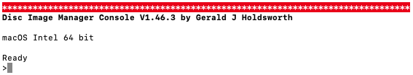

Entering The Console
Adding --console or -c after the binary name, on a command line, enters the console.
--console=<filename> or -c <filename> enters the console and executes the commands in the file <filename>.
There is also --gui or -g to force the GUI to open, and –width=<n> or -w <n> to change the number of columns used by the console (default, and minimum, is 80).

Using the Console
- Command parameters are separated by spaces and are separated from the command by a space. Use quotes (") to enclose parameters containing a space. For example:
  - add "This File.txt" ThatFile.txt
will add a file called 'This File.txt' and another called 'ThatFile.txt' to the image.
- Square brackets [] indicate optional parameters.
- Ellipses ... indicate multiples of the same parameter.
- Bar | indicate to use only one of the parameters.
- Valid wildcards are (commands that deal with the OS may have different wildcards):
  - * : matches 0 or more characters
  - # : matches any character
  - | : when used before a search, it excludes these results from results already found

Console Commands
access <file> [<attributes>]
Changes the file's access rights, or attributes, to those given. Anything invalid is ignored. Filename can contain wildcards.

add <file> [[<file>] ...]
Adds the files/directories listed in the local OS folder. Can contain wildcards.

cat [<option>]
Displays a catalogue listing. If <option> is not given, then the current directory is shown. <option> can be one of the following:
all : Displays a catalogue listing for the entire image.
dir : Lists all the directories in the image.
root : Lists all the roots in the image.
os : Displays a catalogue listing for the currently selected host directory.

chdir [<dirname>]
Changes the host OS directory. If none specified, then the current directory is shown.

config [<setting> <option>]
Sets a configuration setting. Note that not all configuration settings are used by the console and could result in unpredictable behaviour.
<option> can be:
Boolean : True or False.
Integer : Decimal number, unless preceded by 0x, $ or & for Hex number.
String : Anything.
Passing config with no parameters will list the valid options.

compact [<partition>]
Performs a compaction/defrag on the selected partition. If none specified, it acts on the current partition. Same as defrag.

create [<dirname>]
Creates a new directory. If no name given, 'NewDir' is used instead.

defrag [<partition>]
Performs a compaction/defrag on the selected partition. If none specified, it acts on the current partition. Same as compact.

delete <file> [[<file>] ...]
Deletes the files/directories listed. Wildcards not allowed.

dir <dirname>
Changes to directory <dirname>. Use '^' in the path to specify the parent directory.

dirtitle <title>
Changes the current directory title.

eject
Ejects the currently loaded image.

exit [togui]
With no parameter, quits console and application. Adding the togui parameter quits the console and opens the GUI application.

exec <filename> <address>
Updates the execution address for <filename> to be <address>, which must be a valid hex number. Filename can contain wildcards.

extract <file> [[<file] ...]
Extracts all files/directories listed to the local OS folder. Filenames can contain wildcards.

filetocsv <file> [[<file>] ...]
Outputs a CSV format of the specified files. Can contain wildcards.

filetype <hex>|<name>
Translates the hex number to known ADFS filetype, or vice-versa.

find <file> [[<file>] ...]
Finds the files/directories listed in the local OS folder. Can contain wildcards.

free
Displays the free space on the partition/side.

from <file> add|find <file> [[<file>] ...]
Specifies an image file to use when adding or finding files, instead of the local OS folder. See add and find.

help
Displays this text.

insert <filename>
Loads image specified by <filename>.

interleave <option>
Changes the current interleave method and re-organises the data. <option> can be 0, 1, 2, or 3; or auto, seq, int, or mux. Only valid for Acorn ADFS L or FS.

load <filename> <address>
Updates the load address for <filename> to be <address>, which must be a valid hex number.

list <filename>
Displays the file specified (BBC BASIC listing/text output/hex dump).

ls
Display a catalogue of the current host OS directory. Same as cat os.

new <format> [<option> [<option2>]]
Creates a new image:
<format> <option> <option2> Result
DFS S80 Acorn DFS single sided 80 track
DFS S40 Acorn DFS single sided 40 track
DFS D80 Acorn DFS double sided 80 track
DFS D40 Acorn DFS double sided 40 track
WDFS S80 Watford DFS single sided 80 track
WDFS S40 Watford DFS single sided 40 track
WDFS D80 Watford DFS double sided 80 track
WDFS D40 Watford DFS double sided 40 track
ADFS S Acorn ADFS S
ADFS M Acorn ADFS M
ADFS L Acorn ADFS L
ADFS D Acorn ADFS D
ADFS E Acorn ADFS E
ADFS E+ Acorn ADFS E+
ADFS F Acorn ADFS F
ADFS F+ Acorn ADFS F+
ADFS HDD Old map, Old directory 20MB
ADFS HDD OO<cap>[M] Old map, Old directory <cap> size
ADFS HDD ON<cap>[M] Old map, New directory <cap> size
ADFS HDD NN<cap>[M] New map, New directory <cap> size
ADFS HDD NB<cap>[M] New map, Big directory <cap> size
AFS <level> <cap>[M] Acorn FS Level <level> of <cap> size
CFS Acorn Cassette Filing System
C1541 Commodore 1541
C1571 Commodore 1571
C1581 Commodore 1581
AMIGA DD Commodore Amiga DD
AMIGA HD Commodore Amiga HD
AMIGA HDD <cap>[M] Commodore Amiga hard drive of <cap> size
DOS+ 640 DOS+ 640K
DOS+ 800 DOS+ 800K
DOS 360 DOS 360K
DOS 720 DOS 720K
DOS 1440 DOS 1.44MB
DOS 2880 DOS 2.88MB
DOS HDD <cap>[M] DOS hard drive of <cap> size
<cap> is specified in KB, or MB if M is included.

opt <option> [<side>]
Sets the boot option for the current side, or <side> if specified. <option> can be 0, 1, 2, or 3; or none, load, run, or exec.

rename <file1> <file2>
Renames <file1> to <file2>. <file1> can be a complete path, or file in the current directory.

report
Displays the image report.

runscript <filename>
Runs a script. Cannot be used if one is already running.

save [<filename>] [<compressed>]
Saves the current loaded image to the host OS. If a UEF is required to be compressed, pass 'TRUE' as the second parameter.

savecsv [<filename>]
Outputs the contents of the currently loaded image in CSV format.

search <file> [[<file>] ...]
Finds all files/directories listed. Filenames can contain wildcards.

status
Displays the current configuration settings.

stamp <file>
Timestamps the specified file with the current time and date.

title <title> [<side>]
Sets the disc title for the current side, or <side> if specified.

type <file> <filetype>
Updates the filetype for <filename> to be <filetype>, which must be a valid hex number. Filename can contain wildcards.

Credits
Disc Image Manager designed and written by
Gerald J Holdsworth
with additions by
Greg Cook
Phil Pemberton
RISC OS graphics designed by
Richard Hallas
Help and advice from
Jasper Renow-Clarke (ADFS new map)
Robert Sprowson (ADFS new map hard drive parameters)
David Pilling (!SparkFS format)
Jonathan Harston (ADFS and Acorn FS interleaving)
Mark Usher (Acorn FS)
Format sources
BBC Micro Advanced User Guide
BBC Master Reference Manual Part 1
RISC OS 2 Programmer’s Reference Manual
RISC OS 3 Programmer’s Reference Manual
MDFS.net
RISC OS Open Website
Peter Schepers (Commodore 64 formats)
Laurent Clevy (Commodore Amiga format)
This guide written by
Gerald J Holdsworth

